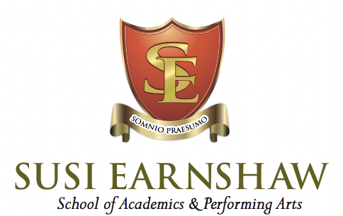

NEWSLETTER

OCTOBER 2021

Auditions for the school started this month with a steady stream of young performers looking around and excited to be in our theatre showing us what they love doing.

The LAMDA Speech and Drama certificates arrived for exams taken just before the summer holidays. These will be given out by Gillian, our speech and drama teacher, next month in a special assembly. Congratulations to all – 90% passing with Distinction and 10% with Merit. These are exceptional results, especially for the pupils sitting grade 8.

Year 11 have written the Christmas Show, “The Elves Who Saved Christmas” and this will be performed by years 10 & 11 on the 4th and 5th December, as part of the annual Barnet Christmas Fayre. Tickets £5 are available on our theatre’s website www.thebulltheatre.com
The show will also be performed on Monday 6th through to Thursday 9th December to pupils from Underhill Junior School and a group of adults with learning difficulties from Mencap. Our year 7, 8 and 9 will be performing a Christmas Carol Concert in Barnet Church on Sunday 5th December.

Our year 11s created a fun a murder mystery game to play with the whole school in the day before we broke up for half term. Groups worked together to solve clues left all over the building and discover who murdered who and where. Pupils’ costumes worn for the non-school uniform day were amazing. Well, we are a performing arts school.

Happy half term.
Susi

